

**Dr. D Y Patil Unitech Society, Pune**

Dr. d. y. Patil arts, commerce & science college

AKURDI, pune

A

Project Report On

“QR Code Attendance Generator”

***Developed by-***

AShwin saini(39)

DILIP HUNDEKARI(17)

Hrishikesh Kadam(23)

2020-2021



**Dr. D Y Patil Unitech Society Pune**

Dr. d. y. Patil arts, commerce & science college

AKURDI, PUNE

DEPARTMENT OF COMPUTER SCIENCE

CERTIFICATE

Exam Seat No:- Date:-

This is to certify that the project entitled **“QR Code Attendance Generator”** is completed by **Mr. Hrishikesh Kadam** Students of **DR. D. Y. PATIL ARTS, COMMERECE & SCIENCE COLLEGE, AKURDI** in fulfillment of M.Sc.(COMPUTER SCIENCE) Project Work in academic year 2020-2021. This is the record of work carried out by them.

**Project Guide Head of Department**

**External Examiner Internal Examiner**

# **ACKNOWLEDGEMENT**

We would like to express my special thanks of gratitude to our Project guide **'Mrs. Rohini Bhoware’** as well as our H.O.D & Vice Principal **Dr. Ranjit Patil** sir who gave me the golden opportunity to do this wonderful project on the topic “**QR Code Attendance Generator**”, which also helped me in doing a lot Research and I came to know about so many new things I am really thankful to them.

Secondly, I would also like to thank guardian and friends who helped me a lot in finalizing this project within the limited time frame.

We are thankful to all fortunate enough to get constant encouragement, support and guidance from all teaching staff of **Department of Computer Science** which helped successfully our project work. Also, we would like to thanks our friends for their help.

## **Index**

**1. Certificate**

**2. Acknowledgement**

**3. Index**

**4. Existing System**

**5. Proposed System**

**6. Scope of system**

**7. H/W & S/W requirements**

**8. Fact Finding techniques**

**9. Diagrams**

**a. ER Diagram**

**b. Class Diagram**

**c. Use case Diagram**

**d. Sequence Diagram**

**e. Activity Diagram**

**f. Collaboration diagram**

**g. Component Diagram**

**h. Deployment diagram**

**10. Testing**

**11.I/O Screen**

**12. Conclusion**

**13. Future Enhancement**

**14. Bibliography**

**EXISTING SYSTEM**

In the present scenario, Teacher has to take attendance of each and every one present in the online class and mark daily attendance.

In this method time as well as physical work is required also there is chance of human error that if anyone joined class late he/she can miss his/her attendance lead to loss of attendance .

Also from teacher point of view maintaining data record and the file in physical file are tedious work to do. Also it is full of risk as anyone can access it and modify the data.

**PROPOSED SYSTEM**

The system lies between online learning and traditional learning as a facilitation for the attendance record-keeping process, in a way that enriches the lecture time so that it can better be utilized in giving useful materials rather than wasting the time taking attendance. The system requires a simple login process by the class instructor through its Server Module to generate an encrypted QR code with specific information. This can be done at any time before the class. During the class, or at its beginning, the instructor displays an encrypted QR code to the students. The students can then scan the displayed QR code using the system Mobile Module, provided to them through the smartphone market by the university. Smartphones may communicate with the server via either the local Wi-Fi coverage offered by the institution or through the internet.

**SCOPE OF THE SYSTEM**

In the proposed scheme, the user can easily and efficiently mark attendance into the system. We analyze the security and usability of the proposed scheme, and show the resistance of the proposed scheme to hacking of credentials, shoulder surfing and flase attendance.

In order to use this authentication system, user need to first register himself into this system by filing up the basic registration details. Once the user is registered ADMIN is responsible for as generation of QR Code, then system will generate a QR Code. Then admin will distribute all the QR codes to the responsible ID’s. Using that code he/she can mark there attendance while the session is ongoing using web cam only.

Also it will generate attendance sheet in Excel file which we can use for further purposes.

**H/W AND S/W REQUIREMENTS**

**Software Requirements**

**Back End :** Python and MySQL

**Hardware Requirements**

* Processor : Pentium IV
* Hard Disk : 200GB
* RAM : 2GB
* Web-cam

**DIAGRAMS**

**ER Diagram**

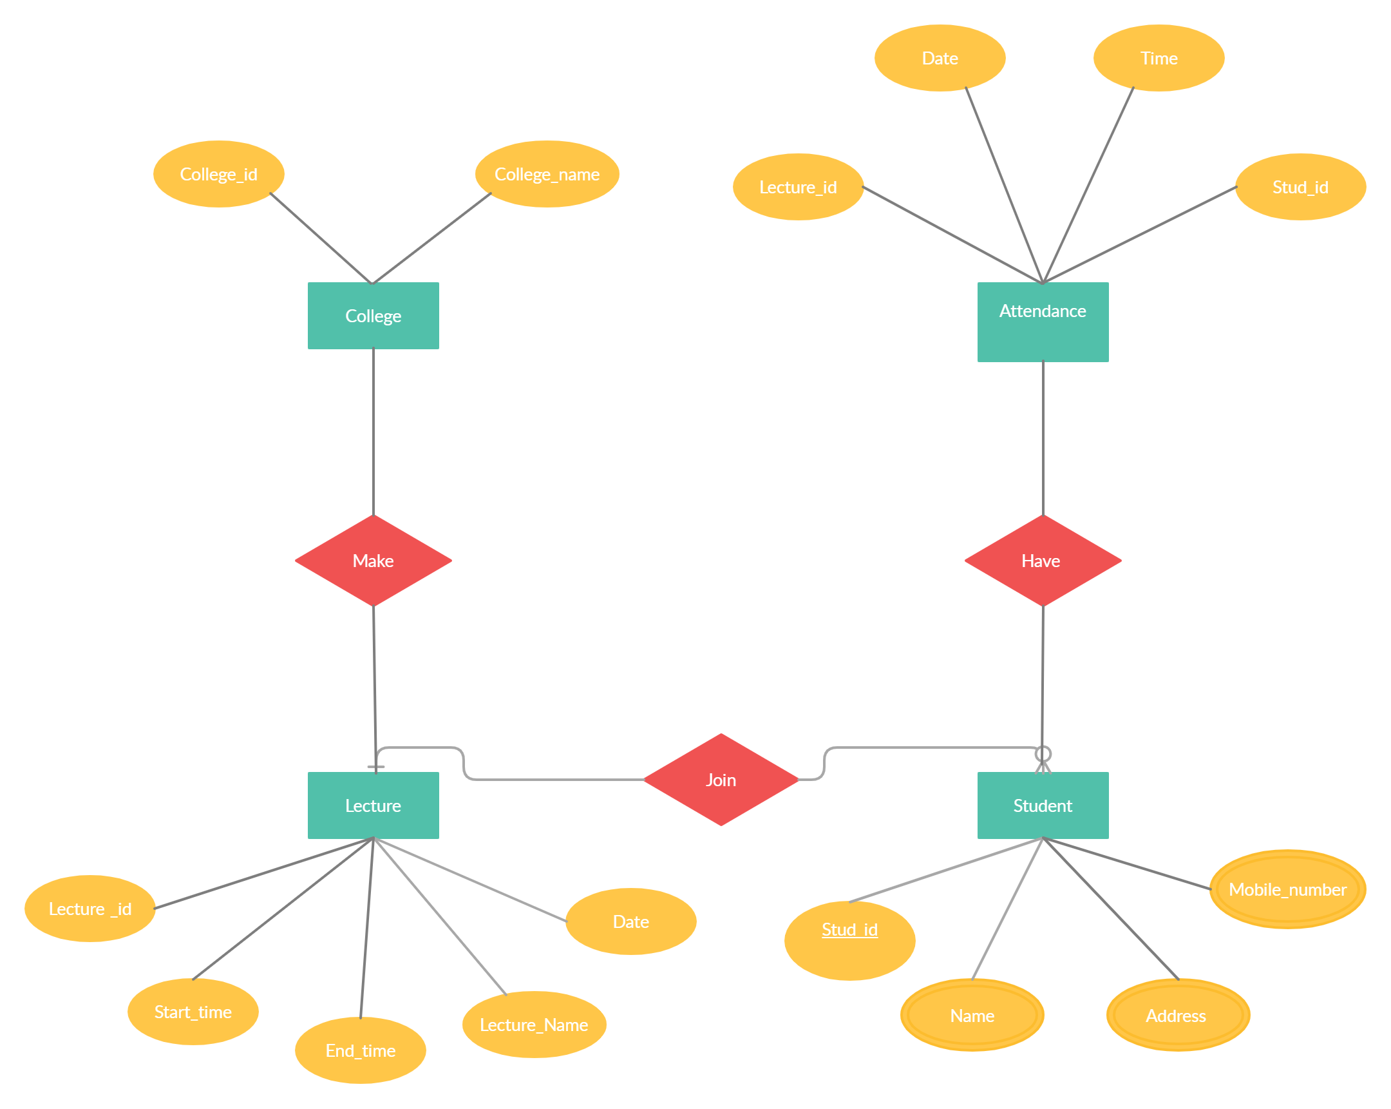

**Class Diagram**

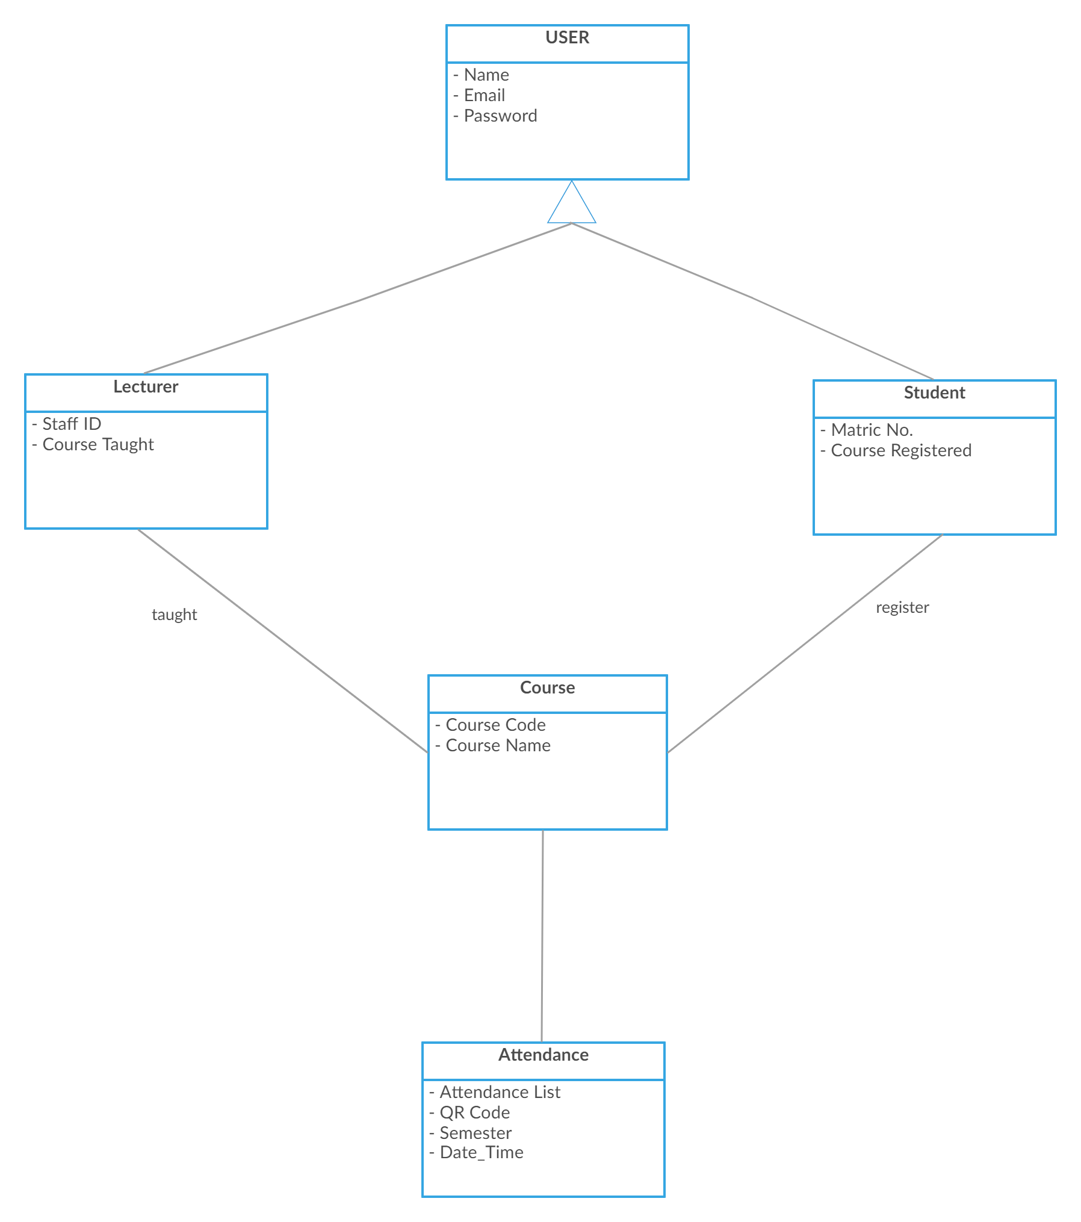

**Use Case Diagram**

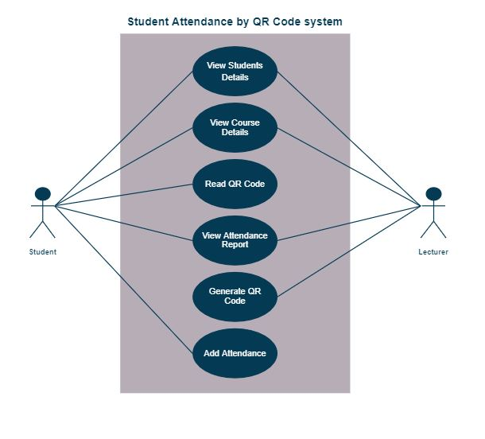

**Sequence Diagram**

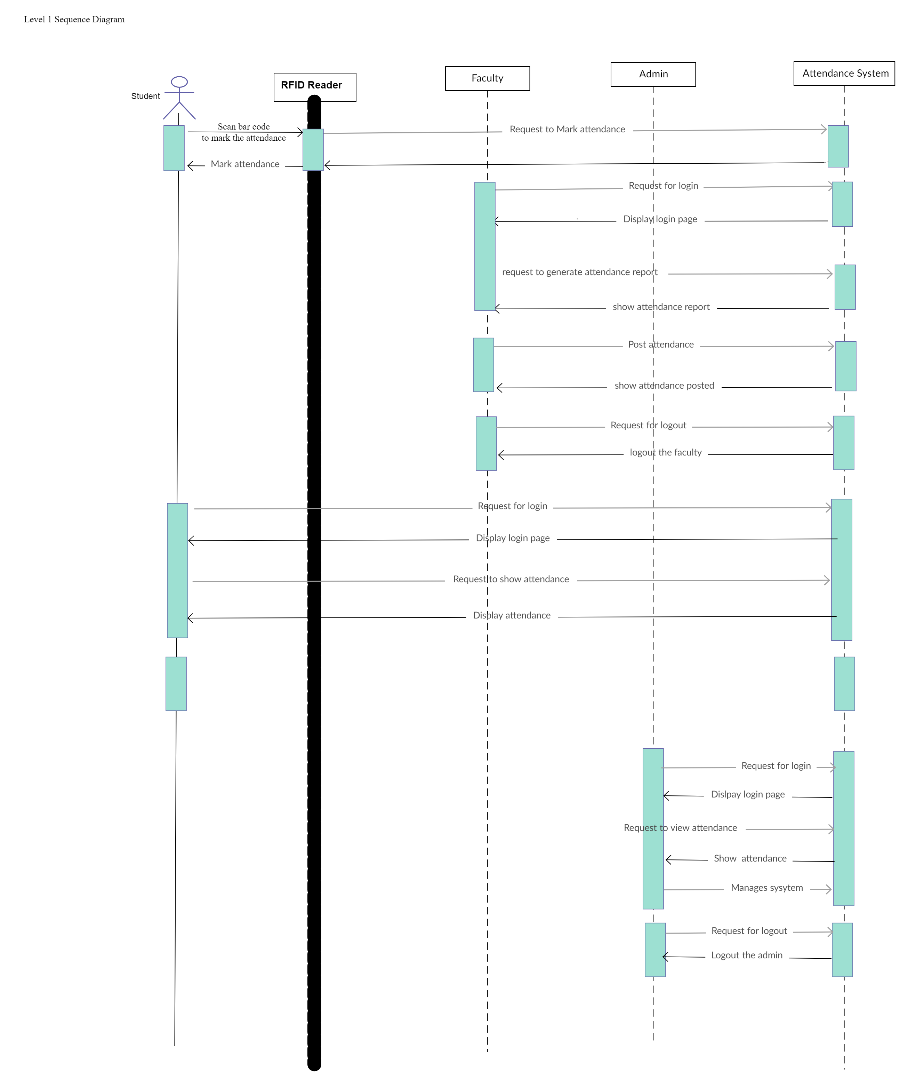

**Activity Diagram**

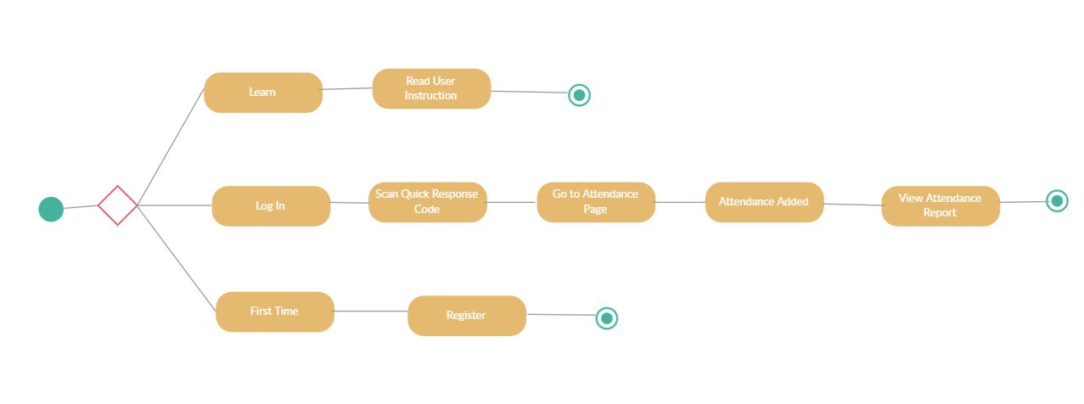

**Collaboration Diagram**



**Component Diagram**

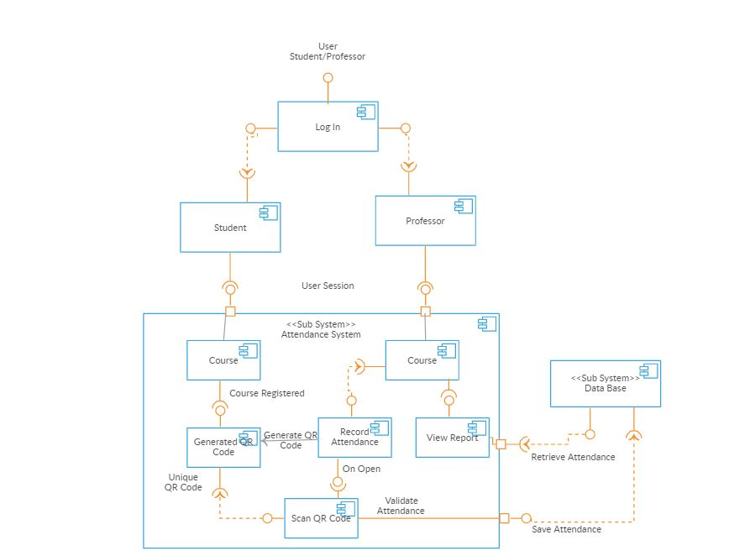

**Deployment Diagram**

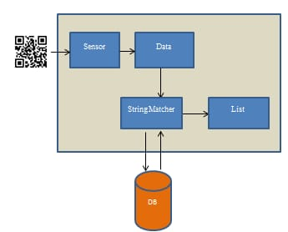

**TESTING**

|  |  |  |
| --- | --- | --- |
| **Test data** | **Expected Output** | **Actual output** |
| Commit changes made in the code. | Will commit the changes in the file. | Commit the changes. |

|  |  |  |
| --- | --- | --- |
| **Test data** | **Expected Output** | **Actual output** |
| Push date. | Push all files to the repository. | Push and upload the file to the repository. |

|  |  |  |
| --- | --- | --- |
| **Test data** | **Expected Output** | **Actual output** |
| Use google chrome pages. | Host the site in google chrome pages. | The site will be deployed. |

**I/O SCREEN**

**Input Screens**

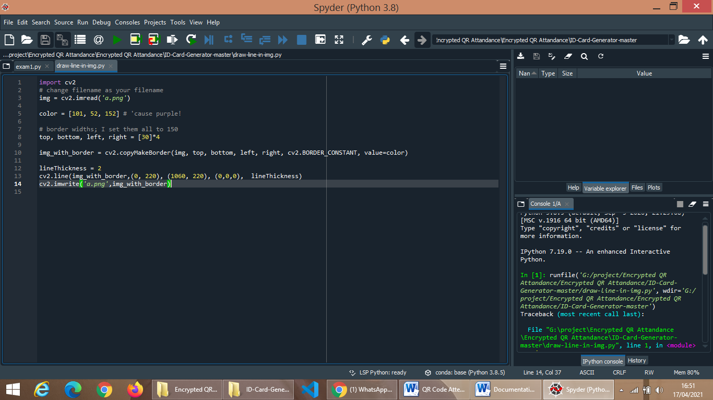

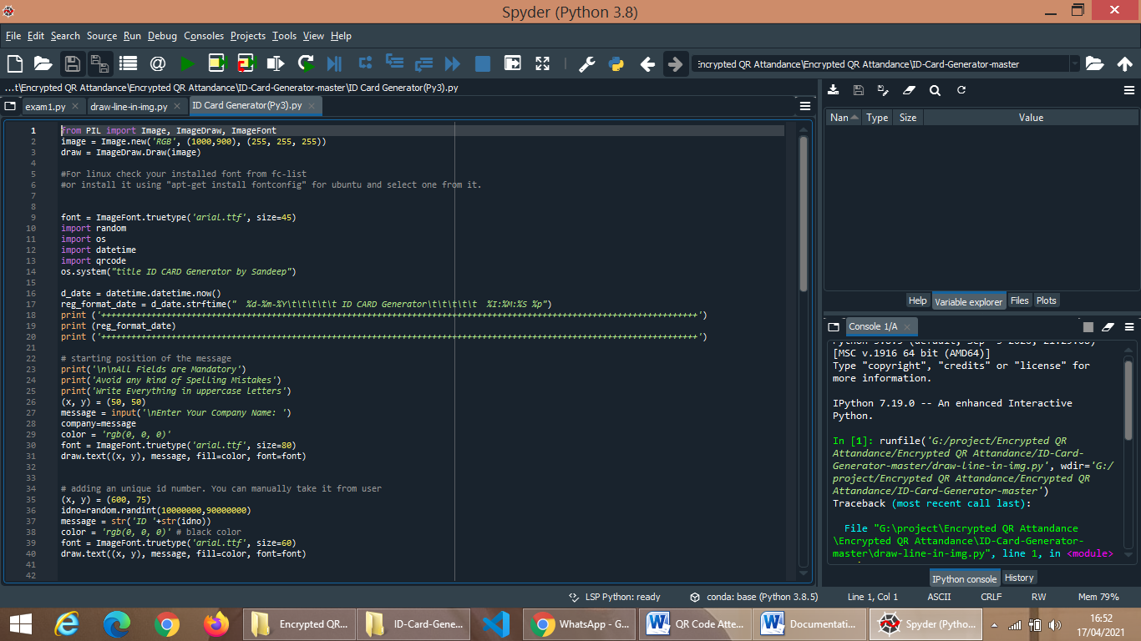

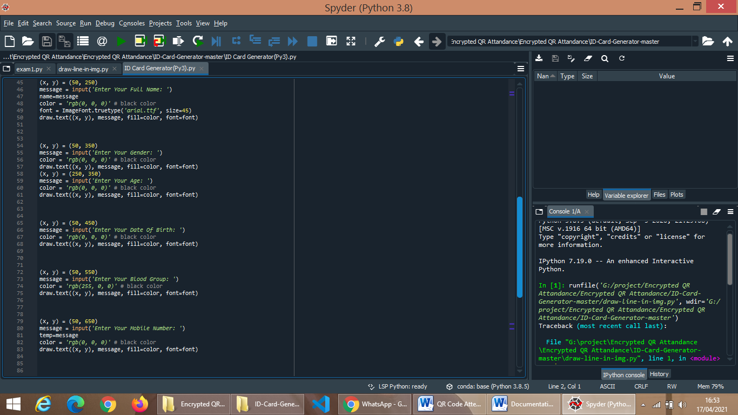

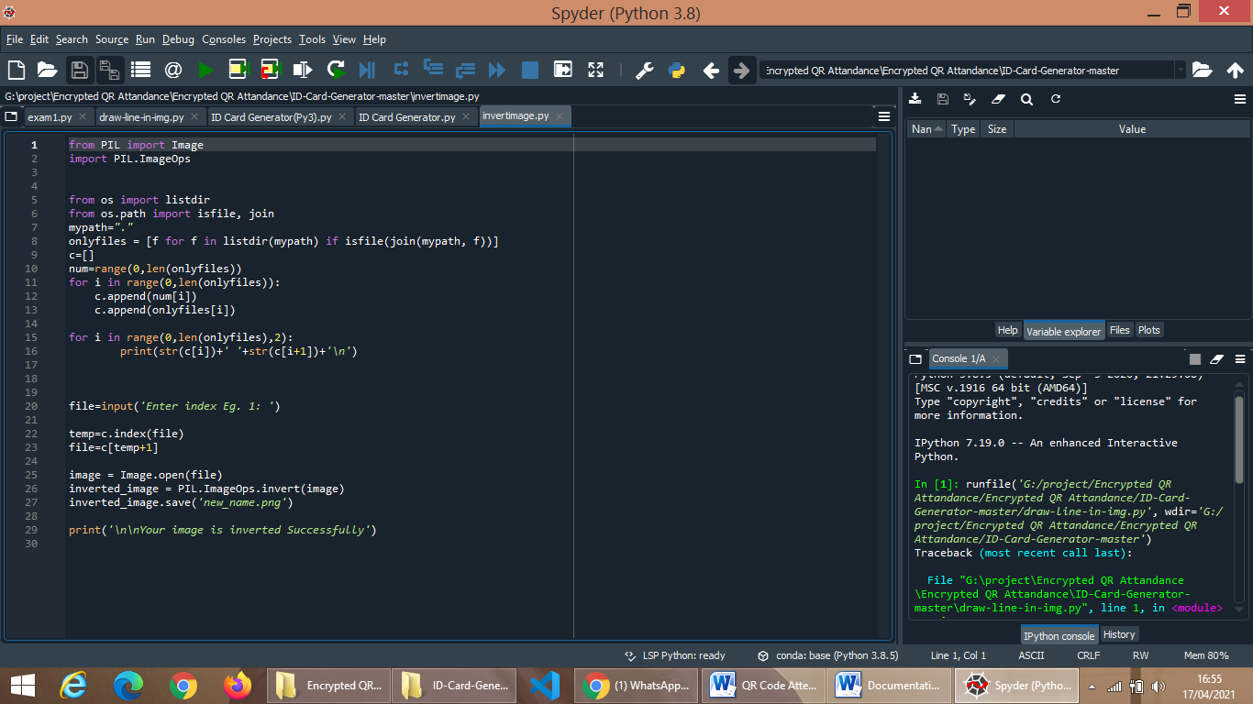

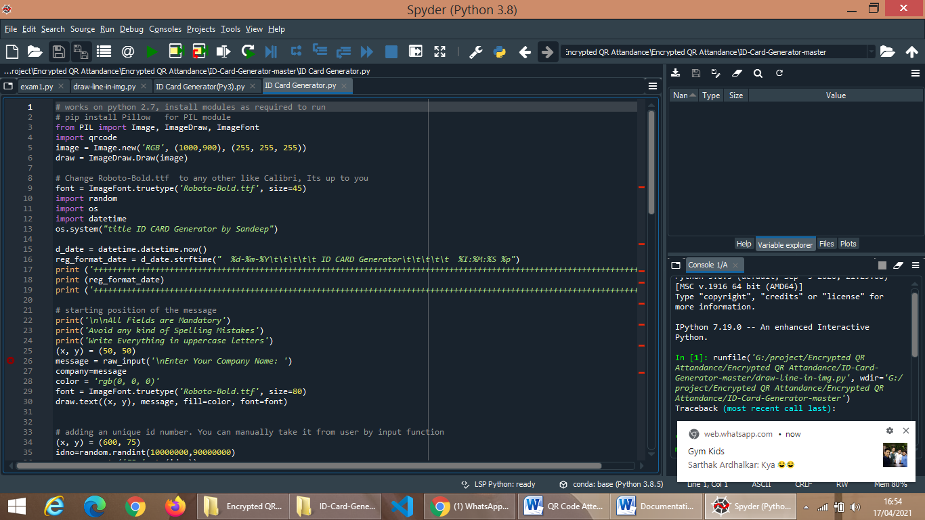

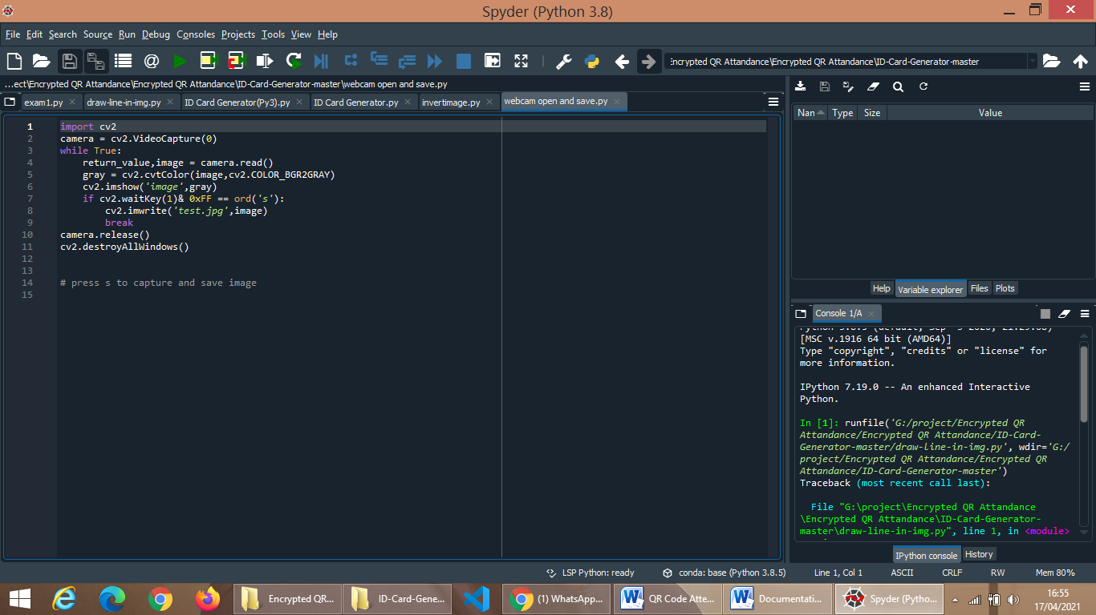

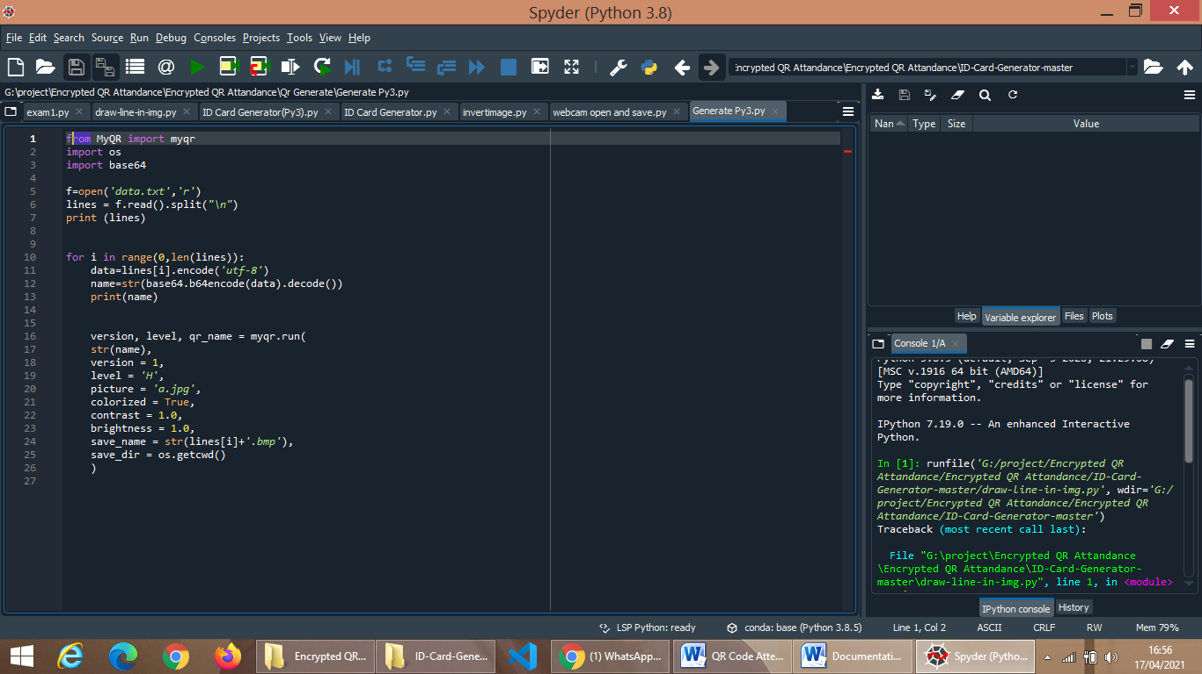

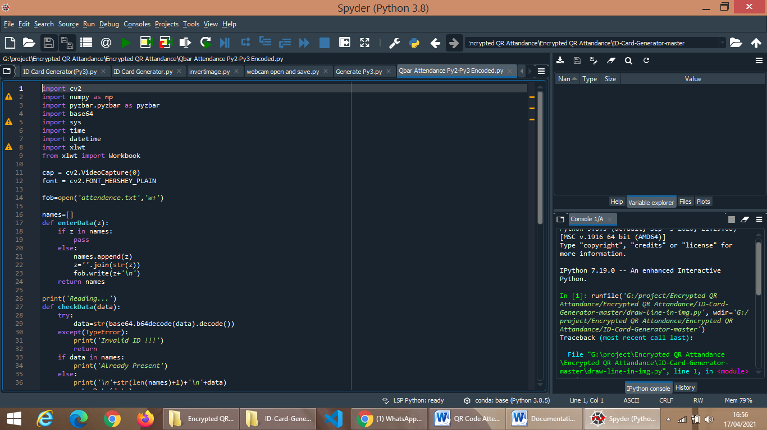

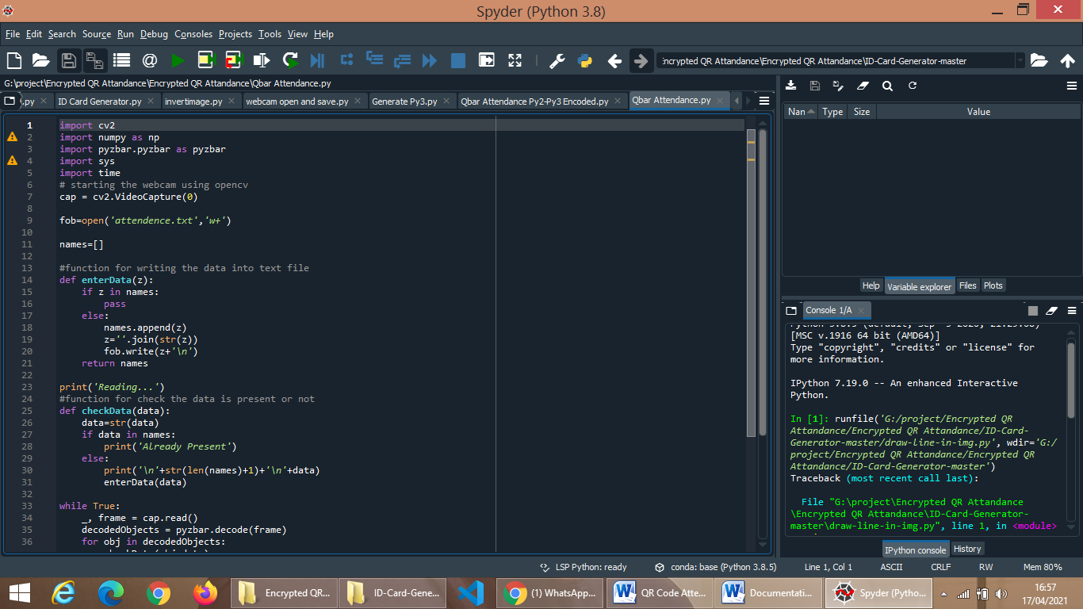

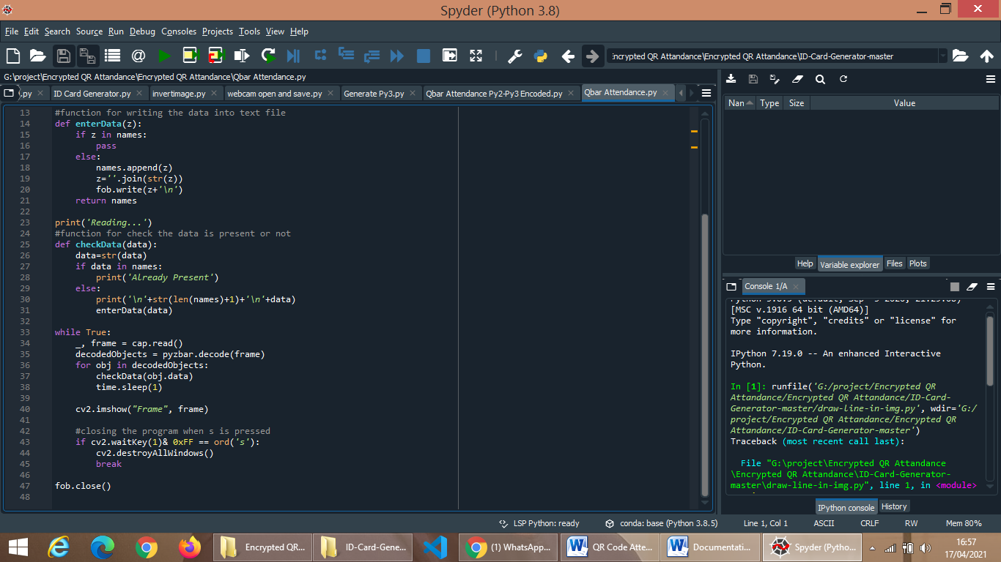

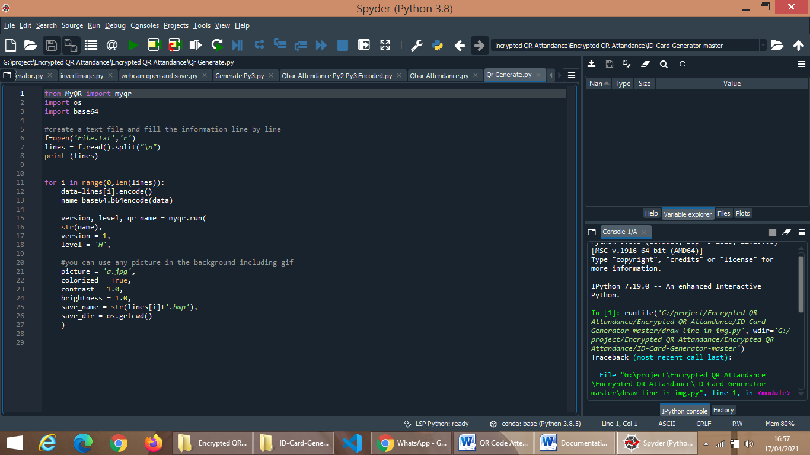

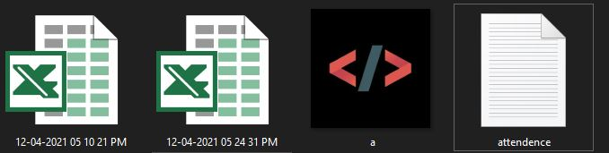**Output Screens-**

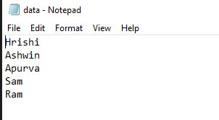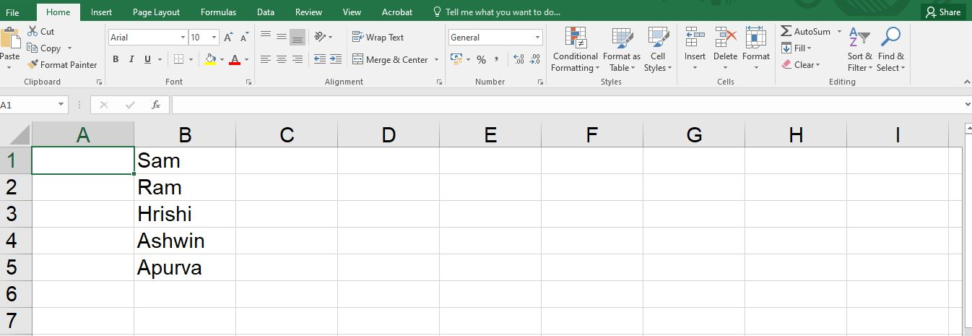

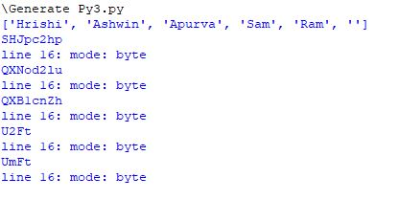

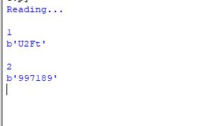

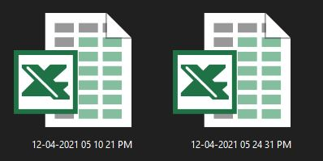

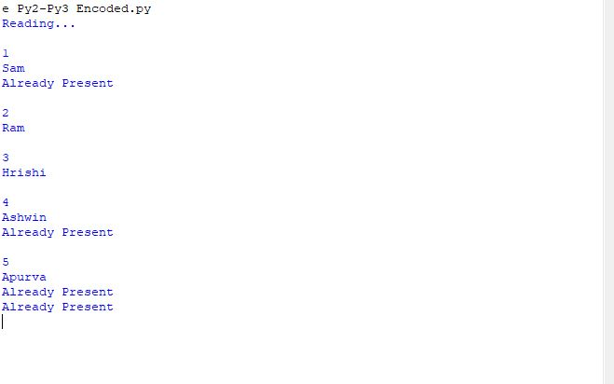

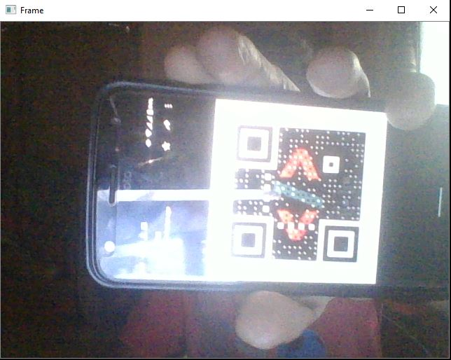

**CONCLUSION**

The developed system presented in this paper has been successfully designed and tested. The student’s attendance status will be analysed and exported. Attendance monitoring system is very important in our daily life. It is possesses a really great advantage, among the whole types of code scanning technology, QR Code Based Smart Attendance System is the most accurate. In this project report, we have given an introduction of Attendance monitoring system and its advantage. It is an efficient method to store the attendance in the smart phone rather than wasting the paper.

**FUTURE ENHANCEMENT**

Our future work will focus on providing missed class topics and notes available to students. Full control to professor with more secured and enhanced options. Finally we conclude, if we integrates this attendance monitoring system with face identification tool then system will solve the real world attendance problem.

**BIBLIOGRAPHY**

**1)** [**https://www.tutorialspoint.com/android/**](https://www.tutorialspoint.com/android/)

**2)** [**https://github.com/zxing/zxing**](https://github.com/zxing/zxing)

**3) http://files.microscan.com/whitepapers/barcode_basics.pdf**

**4) http://androidhive.com**